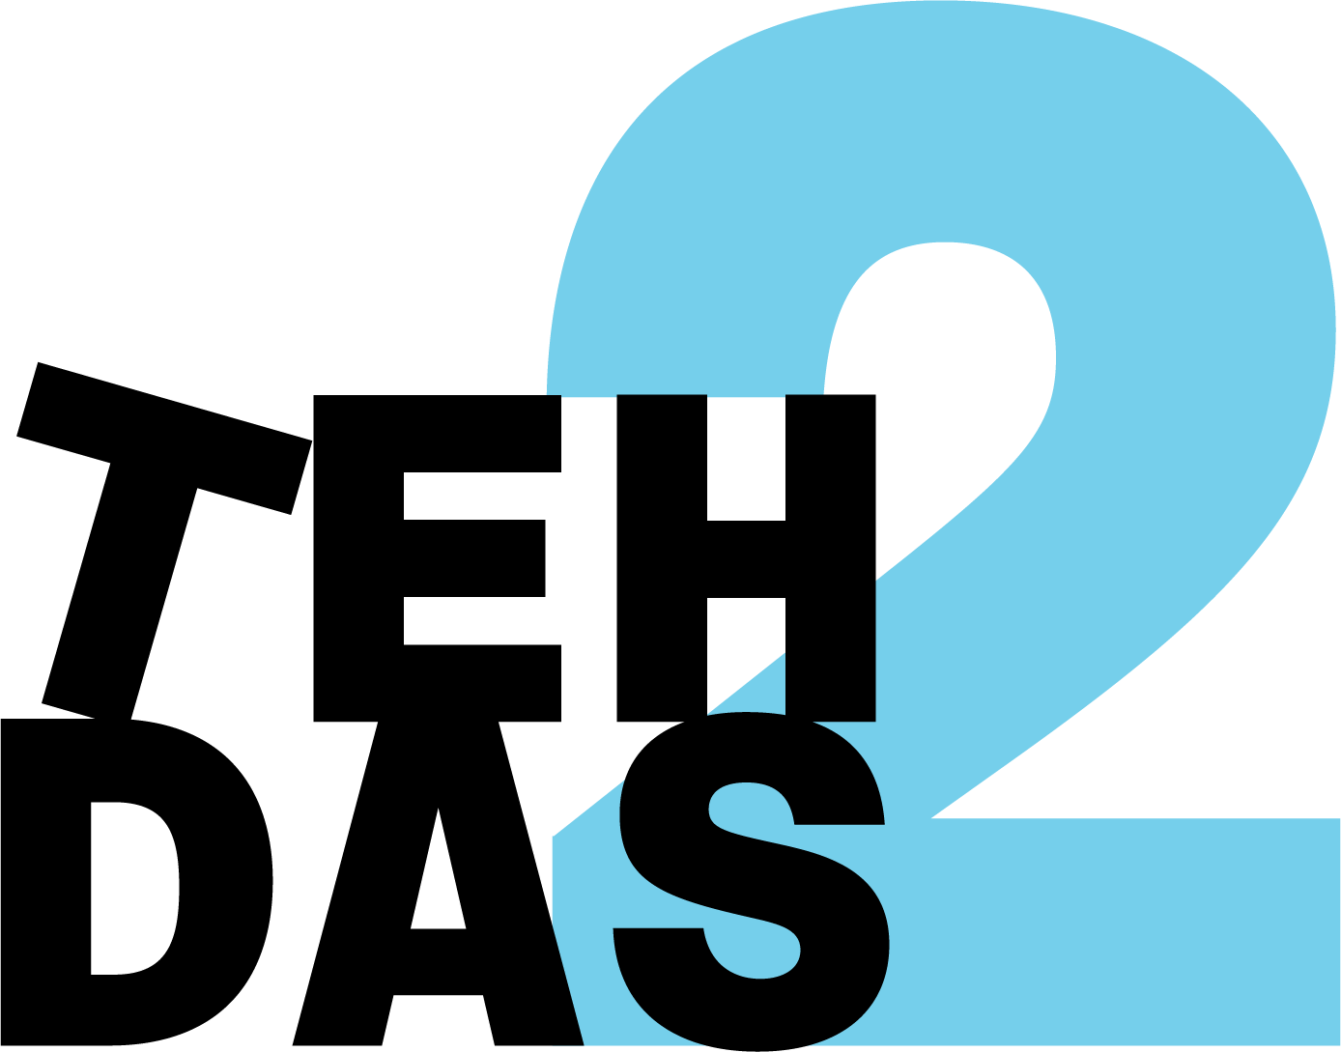

TEHDAS2 public consultation on Draft guideline for data users on handling research outcomes
Mandatory questions are marked with a star (*)
This consultation has 5 pages and 30 questions. The first and the second pages are common to all TEHDAS2 public consultations and cover demography of the responder and overall quality of the document. Pages 3, 4 and 5 consist of questions specific to this document.

Demography
- Country *

Netherlands

2. Type of responder *
Academic or research organisation
Interest group
Individual citizen
Individual expert or professional
Non-governmental organisation (NGO)
Patient representative
Private organisation
Public organisation
Other, research infrastructure

3. Are you responding behalf of several organizations? *
If yes: On behalf of how many organisations?
Yes
No

4. Sector *
Data Management/processing
Education and academia
Government / public administration
Health care administration
Health care provider
Information & media
Information technology
Legal and compliance
Manufacturer of medical devices
Patient advocacy
Pharmaceutical industry
Research and development
Other, research infrastructure

5. Organisation size *
Micro (1–9 employees)
Small to medium enterprise (10–249 employees)
Large enterprise (250+ employees)
Not applicable / Individual citizen

6. Professional role / function
Program manager
Quality

7. Is the document easy to understand? *
Not clear nor easy to understand
3
1
4
Very clear and easy to understand
I don’t know

8. How well does the document address the key issues related to its subject matter? *
Not well
2
1
4
Rate
Very well
I don’t know

9. How feasible do you find the guidelines or technical specifications to implement, as outlined in the document? *
Not feasible and implementable at all
2
1
4
Rate
Very feasible and implementable
I don’t know

10. Generic feedback
Do you have any suggestions for improving the document? Are there any additional topics or areas that should be covered? Max. 5000 characters.
5000 characters left

We observe that the guidelines have largely been developed and described as separate documents by different authors (which is understandable), but therefore there is limited visibility of how they relate to one another within the broader process.
Greater horizontal alignment across the guidelines is needed to support a clear and coherent data journey. This would help stakeholders understand how the different components fit together, ensure consistency across the framework, and facilitate practical implementation throughout the entire data lifecycle.
The implementability of the guidelines is a concern. Implementation should start with a minimum viable end-to-end data journey and evolve through an iterative learning and growing process. Rather than regulating all details from the outset, requirements should be introduced in phases, allowing experience and evaluation to inform further development and requirements.
At the same time, sufficient harmonisation is needed to prevent divergent national interpretations and implementation approaches. Therefore, each phase should include clear, directly applicable requirements that ensure consistent implementation across Member States growing into a more robust and mature legislation.

The following questions are specific for TEHDAS2 Draft guideline for data users on handling research outcomes
11. Is the scope and aim of the guidance clearly described in the Introduction (i.e. handling of research and innovation outcomes under the EHDS)?
Yes, however the scope is quite limited in relation to the aim of the guideline.

12. Are the key concepts (e.g. “outcomes”, “results”, “outputs”) clearly defined and used consistently throughout the document?
No – please explain
What is covered by output? Do newly generated datasets fall under this? Is it only the result of the data processing? Examples would be helpful.
The terms research outputs and outputs are used interchangeably, it is not clear whether this has the same definition.
The guideline is called research outcomes when it appears to refer to all outcomes in a broader sense.
Significant findings are also not sufficiently defined as a concept.

13. Is the intended target audience (secondary data users) clearly identified andconsistently addressed throughout the document?
Yes

14. Is the relationship between the EHDS Regulation and the GDPR forsecondary data users explained in a clear and legally accurate manner?
No – please explain

Data can be anonymous in different phases under the EHDS – data could already be anonymous for the dataholder, it can be anononimised before entering the SPE or only be anonimised before export of results. A clear overview of GDPR applicability in these different phases is needed. For instance: are GDPR obligations (eg. Art. 13 and 14) applicable, even if the data becomes anonymous in the SPE?
The guideline may benefit from mentioning that the EHDS not only complements the GDPR but also explicitly builds upon its legal bases for the processing of personal data. As such the relation between personal data use under the EHDS and earlier made agreeements with data subjects may become more clear.
Moreover, section 4.2.1 explains that where processing involves personal data, the GDPR remains applicable. However, in light of Recital 26 GDPR, Breyer case and SRB case the applicability of the GDPR (to the recipient) with regards to personal data received in a SPE can be questioned. This document includes no mention of this ‘relative character’ of personal data (towards the recipient).

15. Does the document clearly distinguish between legally binding obligations and non-binding recommendations or good practices?
No – words as should, may, can, could cause confusion when attempting to make this disctinction. Explicitly state what is a legal obligation derived from the regulation and what is a recommendation by the guideline.

16. Are lawful bases for processing, accountability, and controller responsibilities of secondary data users sufficiently clear and accurate?
No – please explain
Elaboration is necessary. Some relevant articles are stated but accountability and responsibilities go beyond what is mentioned. For instance the reporting of significant findings is briefly mentioned in table 1, but there is no explanation of for instance the role of national law within this component of the EHDS.
Another example is that section 5.1 states ‘Accountability in this context relates to(…)’. The significance of this section may not come across effectively where it is placed now in the text. Such statements would benefit from more explanation or a more logical placement in the text.

17. Are the roles and responsibilities of secondary data users, HDABs, andhealth data holders clearly distinguished particularly with regard to outcomehandling, reporting, and dissemination?
Yes

18. Does the document appropriately integrate ethical standards (e.g. research ethics, public interest, proportionality) into guidance on outcome handling?
Yes

19. Is the guidance on clinically significant findings sufficientlyclear, accurate and actionable for secondary data users?
No – please explain
It is not sufficiently defined what is classified as clinically significant findings. Additionally, a description of the position of national law in this context is underdeveloped. There is no mention of a previous guideline on this topic, which could contribute to the reader’s understanding of this concept within the EHDS framework.
The lack of definition of clinically significant findings within this guideline and the EHDS itself, gives rise to uncertainty as to when and what steps to undertake as a data user.
Moreover, how should a data user, and subsequently that specific data holder, who has got the data from one source be sure that the data subject had not already received notice on the finding through another source?
Finally, it should be acknowledged that different data holders may have diverging reporting mechanisms towards the data subject (e.g. different rules/ mechanism may apply/suit better for wellness apps as opposed to general physician).

20. Are governance boundaries (prohibition of re-identification, notification via HDABs, role of data holders) clearly and consistently respected?
Yes

21. Are the constraints related to secure processing environments (e.g. output control, export limitations) realistically reflected and manageable in practice?
No – what can happen with newly generated datasets? Could another guideline on this topic be referred to?
The question arises whether peer review can be possible if reviewers cannot view data to draw conclusions on the quality of the research.
While section 4.2.2 specifies which data may be exported from the SPE it fails to include the possible effects of Article 51 (3) and Recital 57 EHDS, which lay down that member states may establish rules for the processing and use of data containing improvements related to the processing of those data based on a data permit. How should member states interpret output control restrictions with regards to enriched datasets (within the SPE)? Should these enriched datasets be considered ‘output’ of the research?

22. Does the document strike an appropriate balance between enabling innovation/IP generation and safeguarding transparency, public interest and EHDS objectives?
No – It is unclear which law is considered to be the “applicable law.” Is this the law of the nationality of the user, where the user/institute is established, or is it dependent on where the data originates from?
The role of the HDAB in this context should be described more elaborately. For instance, it is not expressed whether the HDAB will oversee the additional contracts between parties.
There is no practical guidance on how to strike a balance between innovation/IP generation and safeguarding transparency and public interest.

23. Are expectations regarding transparency and reporting of commerciallyrelevant outcomes clear and proportionate and correctly limited to what is required under the EHDS framework?
No – This is explained in the guideline to an extent, but there is a lack of guidance on practical implementation.

24. Are dissemination and reporting obligations for research, policy, andoutcomes related to product or service development (Article 47 EHDS) clearlydescribed?
Yes, but art 47 is not mentioned in the guideline itself, this should be elaborated.

25. Do you consider the proposed timelines and reporting practices realisticand feasible for secondary data users in practice?
No – There is no explicit mention of a timeline, however this may also not be especially relevant for this guideline.

26. Is the guidance on data sharing and collaboration aligned with EHDS governance and sufficiently clear for secondary data users?
No – please explain
The guideline provides limited information on rules for collaboration.
Mixed and newly generated datasets are not addressed as such. It is unclear what does/can happen with newly generated datasets, for instance when sets from different states are combined- is it possible to reuse these datasets? It is also unclear who is then responsible for mixed datasets. It is unclear whether there is a specific existing guideline on enriched datasets, and what that guideline concludes.

27. Are cross-border and international collaboration aspects adequatelyaddressed, in line with the responsibilities of secondary data users under theEHDS?
No – The definition of what is classified as applicable national law must be discussed.
Another issue that should be addressed is the possible discrepancy of ethical considerations by researchers in different member states, for instance in relation to significant findings.
A reference to another guideline on international collaboration could provide better context.

28. Do you expect this guidance to have a practical impact on your organisation’s or your own activities as a secondary data user under theEHDS?
No – at this stage issues are identified but practical guidance is lacking.

29. Which sections of the document, if any, require the most improvementbefore finalisation?
Max. 5000 characters.
5000 characters left
The majority of feedback on this guideline is applicable throughout the sections. However, certain sections require more improvement than others. In the section on outputs, an important addition is the topic of newly generated data sets. It is unclear whether enriched data sets or mixed data sets can be saved for reuse by different data users. If this were to be possible, it should be explained how this will be effectuated in practice and who will be responsible for said datasets.
The topic of significant findings is specifically underdeveloped in terms of definition and practical applicability. Although other guidelines may elaborate on this topic further, it is directly related to research outcomes. For the value of this guideline, at minimum, a clear definition of a significant finding should be included, as well as an indication of which party carries the responsibility to communicate such findings.
Finally, the section on Intellectual Property and Commercialisation requires further guidance. It is expressed when IP applicability should be indicated in the data requesting process. Nonetheless, it is not mentioned what the potential consequences are for processing a data request when IP can be indicated at different stages. The definition of “applicable law” also requires further clarification.

30. Any additional comments or concerns regarding the handling of research outcomes under the EHDS that are not covered above?
Max. 5000 characters.
5000 characters left
Certain structural and formatting improvements could be made to the document. For instance, there is a lot of repetition throughout the document. Points are often substantively the same, yet rephrased multiple times. Additionally, the terms “HDAB” and “Health Data Access Body” are used interchangeably. For formatting purposes, one of the two should be consistently used.
A general point of feedback is that the document presents a strong emphasis on compliance with the EHDS, without offering sufficiently elaborate guidance on how to achieve compliance in practice. Ambiguities in interpretation or practical consequences of compliance are often not further discussed. For example, it is stated that health data holders must identify parts of their dataset which may require additional protection of intellectual property, either when providing the dataset description or when requested by the HDAB. These two options may have a different impact on the way in which a request for that data set is handled, hence impacting the outcome. Nonetheless, the evaluation in the guideline ends at stating these two options. A more critical analysis of the implications would improve the guideline.
Additionally, certain topics are not covered by the guideline but arguably could fall under its scope. For instance, the possibility of peer review under the EHDS, specifically the ability for reviewers to view data in order to assess the quality of the research, is not explored. Since data is in a Secure Processing Environment, a reviewer does not necessarily have access to this, impeding the ability to draw conclusions on the quality of the research outcomes. Another TEHDAS guideline (D6.2: Guideline for data users on good application and access practice) touches on this topic.
Since many guidelines exist on specific EHDS topics which overlap with other guidelines, it would be very helpful to refer to existing guidelines, for instance with a hyperlink or reference. This would avoid going beyond the scope of the specific guideline, while redirecting the reader to additional contextually relevant information.
The guideline at times refers to outcomes having to be in line with the awarded permit. However, this is not always consistent with the information that will in reality be included in the permit. This should be corrected.
Another relevant point that should be developed further is the role of the HDAB, specifically in relation to ensuring compliance with national standards. Certain responsibilities of data holders and data users are derived from national law. It is unclear to what extent the HDAB has a role in ensuring such norms are complied with, and how that will fit into the national system of member states.
Furthermore, the role of the HDAB in facilitating proper interpretation of data is not addressed. In order to ensure the possibility of high quality research outcomes, a data user must be able to interpret data, by for instance gaining contextual insight. Currently, it is common for data users to be in contact with the data holder to receive this additional support in interpreting data. Under the EHDS such contact may be hindered, and it is unclear whether the HDAB can (and should) have a role in facilitating the interpretation process to benefit the outcomes.
Finally, in order to ensure full transparency, the guideline could opt for an obligation for outcomes to be published with open access, meaning not subject to a paywall for instance.

